Appointment bookings
Appointment bookings are required for passport applications and notarial services. Clients without an appointment will only be seen in exceptional circumstances. Appointments can be booked here Appointments are not required for enquiries or passport collections.
Booking policy
Clients should arrive 5 minutes prior to appointments for security screening. If you arrive late for your appointment you may need to wait until an officer is available.
We request that you do not book more than one appointment. Refer to your notification email if you need to amend or cancel your appointment (see example below).
Please ensure you select the correct type of service when you make the appointment. If you select the wrong service, we may not be able to help at your appointment time.
Why appointments?
The Australian Embassy introduced passport and notarial appointments the following reasons:
- provide a better service to clients by reducing wait times
- balance demand for our services throughout the week from peak periods
- increase the efficiency of passport and notarial services so that we can increase and improve

How to book your appointment
To book appointments please visit here
Steps to booking:
- Select your desired service.
- You will automatically be forwarded to the next available appointment. You may select a date or time between today and 2 months in advance. First select the date on the calendar then choose the time.
- Enter your information. We ask you to list an email address and a phone number so that you can receive appointment reminders and we can contact you if necessary.
- Agree to our cancellation policy. If you need to cancel or reschedule your appointment, please refer to instructions below.
- Attend the Consulate at your designated booking time.
Cancelling or rescheduling an appointment
You will receive an appointment cancellation/modification link each time you book an appointment at the Consulate. The Embassy sends email notifications when an appointment is booked. It will appear as per below:
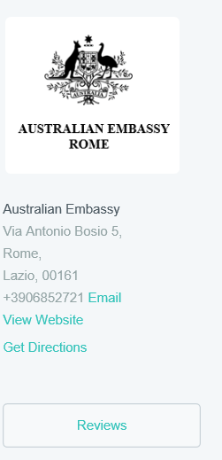
If you want to cancel an appointment, please click the "Cancel Appointment" link and you will receive a message on a new tab asking you to confirm cancellation.
If you want to modify an appointment, please click the "Reschedule" link. You will receive a message on a new tab allowing you to reschedule your appointment.
If you have any enquiries, please email us at consular-rome@dfat.gov.au
Fees
Fees vary month to month, up-to-date fees are available here.
Disclaimer
The Department of Foreign Affairs and Trade is not responsible for any loss or damages whatsoever arising out of or in connection with the online appointment booking system. The Department of Foreign Affairs and Trade reserves the right to omit, suspend or edit all information and/or services provided at any time in its sole discretion without giving any reason or prior notice. You are responsible for keeping apprised of all information and/or services provided in this booking system.
Privacy Policy
The Australian Embassy will never provide your details to anyone else; however, we do use third party software to manage the appointment bookings. The Department of Foreign Affairs and Trade\'s privacy policy can be viewed http://dfat.gov.au/about-us/about-this-website/pages/privacy.aspx.
The Department of Foreign Affairs and Trade (DFAT) uses third-party software (Setmore) to manage Embassy`s appointments. Your personal information (including your name and contact details) will be collected by DFAT via Setmore to book your appointment and for related purposes. By proceeding with this booking, you are consenting to the collection of this information by Setmore on DFAT’s behalf for these purposes. If this information is not collected, DFAT’s ability to arrange your appointment will be limited. Your personal information will be handled by Setmore in accordance with Setmore’s Privacy Policy, and by DFAT in accordance with DFAT’s Privacy Policy.

